Notes 6.3: Writing Cube Root and Cubic Equations from Graphs and Descriptions & Analyzing Intervals
Algebra 2

Write equations from Descriptions
Examples

1. Write the equation for a cubic function that is vertically stretched by 3, horizontally compressed by ½, reflected over the x-axis, shifted right 2 and down 4.

2. Write the equation for a cube root function that is vertically compressed by ½, horizontally stretched by 4, shifted left 5 and shifted up 2.

Write equations from Graphs
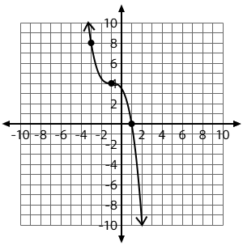
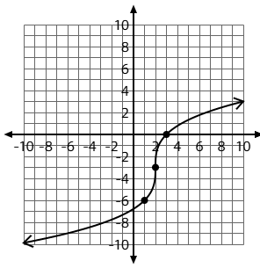
Examples: Write a cubic or cube root equation for each of the following graphs.

3. 4.

Analyzing Intervals and their attributes

For each of the intervals, identify the requested information.

Examples
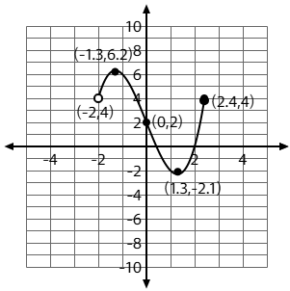
1. For the graph at the right, identify the following:
Domain:

Range:

x-intercept(s):

y-intercept(s):

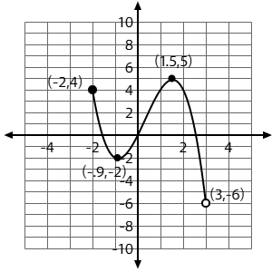
2. For the graph at the right, identify the following:
Domain:

Range:

x-intercept(s):

y-intercept(s):

